|  |  |
| --- | --- |
|  | WIL Project |
|  |  |
|  | Brandon Goncalves, 20240835  Programming Foundation  10/31/24 |

Table of Contents

WIL Project: Project Requirements and Scope 2

Project Requirements and Scope 2

UI/UX of the real estate listing website 4

Wireframes of my RealHome Website 4

User Registration and Login 4

Home Page 4

Buy 5

Rent 5

Sell 6

Agents 7

Favourites 7

Wishlist 8

Code and Database Screenshots 9

Code 9

Register and Login Code 9

Home Page Code 12

Buy Property Code 13

Rent Property Code 16

Sell Property Code 19

Agents Code 21

Favourite Code 22

Wishlist Code 24

Database 27

Real Home User Database 27

Real Home Properties Database 28

References for resources used in WIL Project 29

Task Completion Checklist 30

Task completion checklist 30

# WIL Project: Project Requirements and Scope

## Project Requirements and Scope

The project requires me to create an online platform for real estate agents and homeowners to list properties for sale or rent. The website allows users to search for properties based on criteria, allows users to view detailed information about each property listing, and it allows for users to contact the listing agent or the owner of that property they are interested in.

I need to design this online property listing platform and ensure that it has a user-friendly interface for listing and searching properties, meaning that users are easily able to search for properties that they may want to acquire or rent out. I need to implement a robust database to store property details, I need to store user details and I need to ensure that there is a database for agents and property owners for users to contact. I need to ensure the website is also responsive and that users can use this website on various devices, such as laptops computers, desktops and mobile devices. I also need to ensure a user authentication system, so users would need to log in before they are able to use the actual website.

The key features of this website are that users are able to log in and register their accounts, it needs to secure user accounts for agents and potential buyers/renters of property, I need to add property listings functionality, so users can add, edit or remove property listings, there also needs to be search and filter functionality so users can search properties by location, price range, property type and other various property criteria such as bedroom amount or bathroom amount.

There also needs to be a property details page, which shares detailed information about each property, including photos, property descriptions, amenities and contact information for the property. There needs to be an interactive map where it shows the property location. The website needs to include agent profiles, so profiles for real estate agents and their listings, along with their contact information. I need to add a favourite and Wishlist so users can save their favourite properties and they can create a Wishlist for properties they may want to acquire or rent out.

Additionally, the website needs to have mobile responsiveness, meaning that the website is able to fully function even when ran on mobile devices. This means that there is not only laptop or desktop computer functionality, it needs to accommodate mobile device users. Lastly, there needs to be a contact form, where users can contact agents and/or property owners directly through the website, this can include emails, contact numbers and telephone numbers.

The technologies and requirements that are going to be used to construct this entire project are, HTML, CSS and JavaScript to code the entire front-end of the website, this is to ensure that the designs come into play and it ensures that there is functionality to the website itself. For the back-end of the website, I will be using PHP. For holding information such as user details and property information, I will be using the MySQL databases. APIs such as Google Maps API will be used to show property location and I will use an Email API for notifications from the website to the users. For website hosting I will be using AWS to host the website online, and lastly, I will be using Git and GitHub for the version control of the website.

Through using these project requirements, I need to create a functional and outstanding website. At the end of making this project, I expect to have a fully functional real estate listing website that showcases web development, it showcases database management and lastly it needs to showcase proper user interface design.

# UI/UX of the real estate listing website

## Wireframes of my RealHome Website

### User Registration and Login

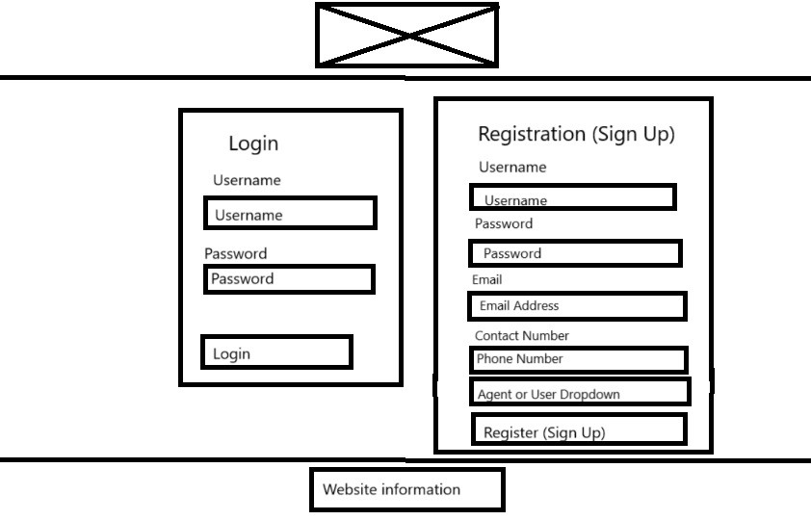

### Home Page

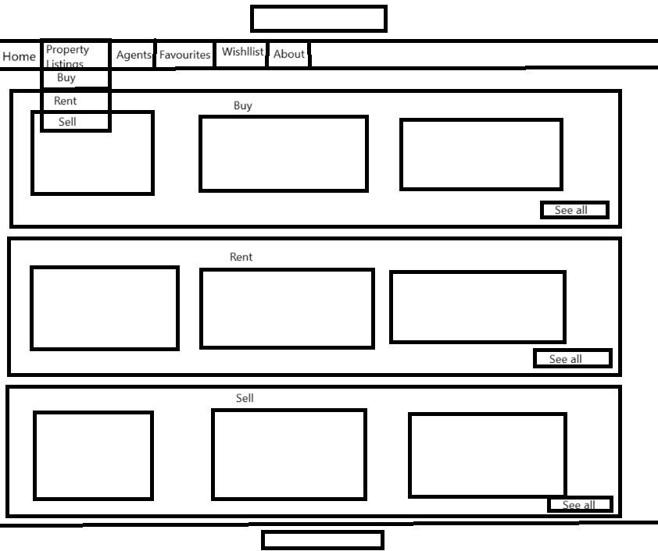

### Buy

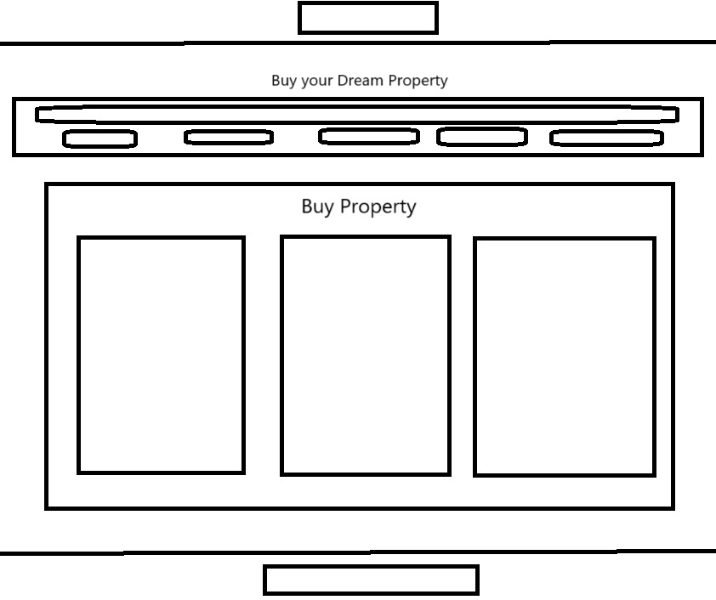

### Rent

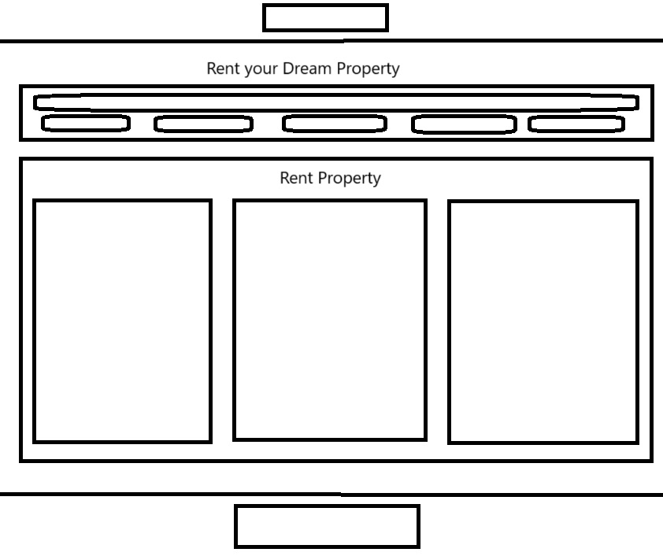

### Sell

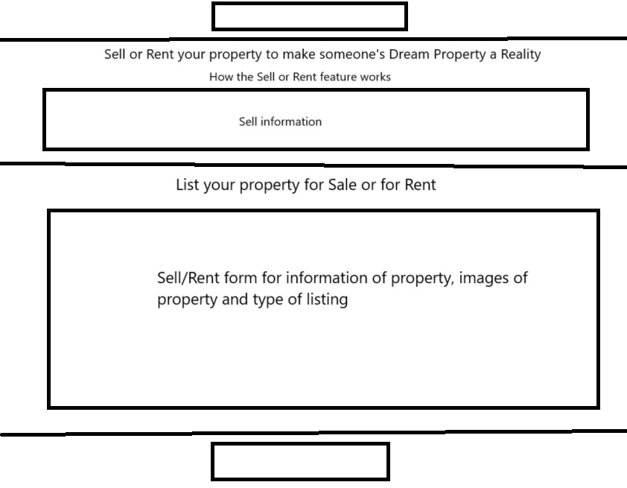

### Agents

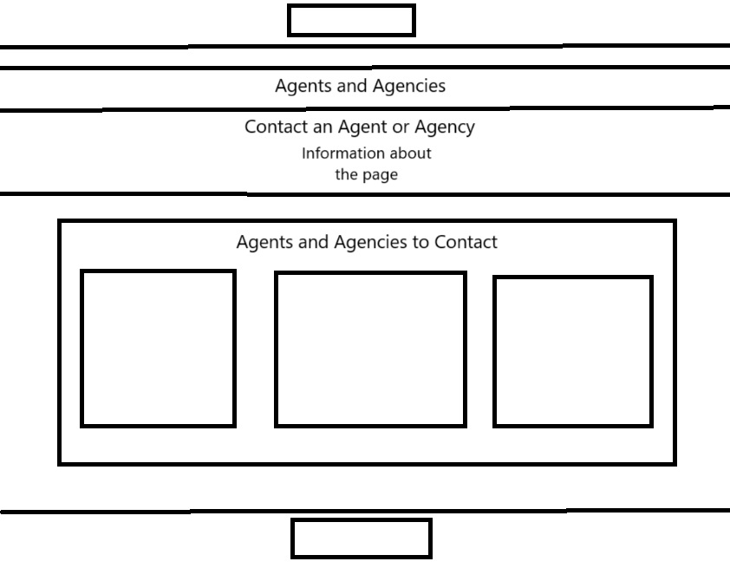

### Favourites

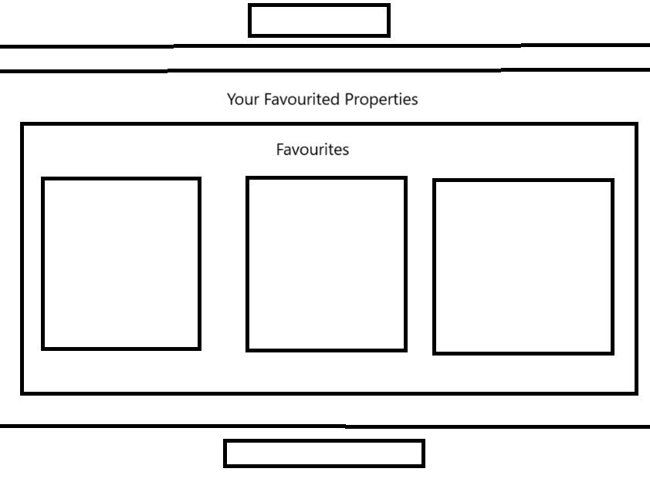

### Wishlist

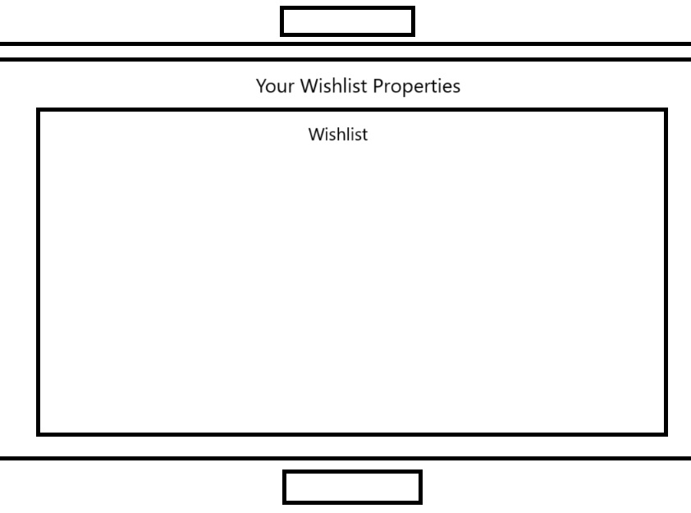

# Code and Database Screenshots

## Code

### Register and Login Code

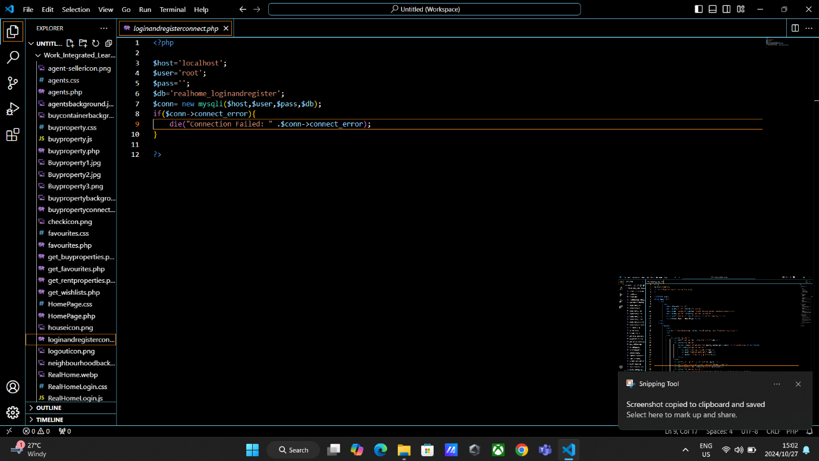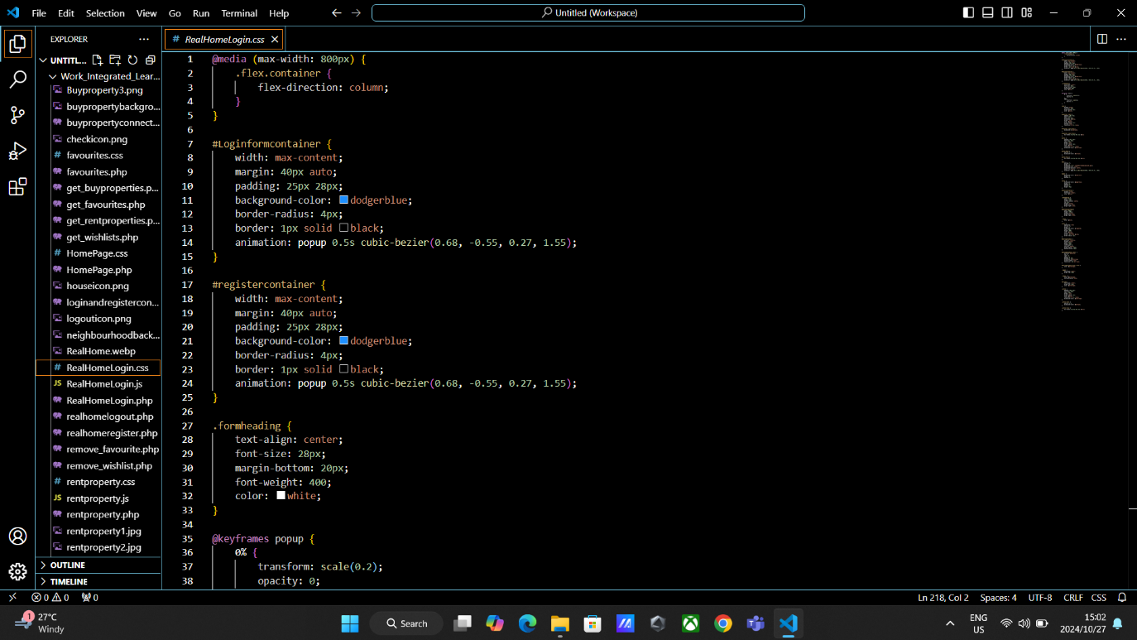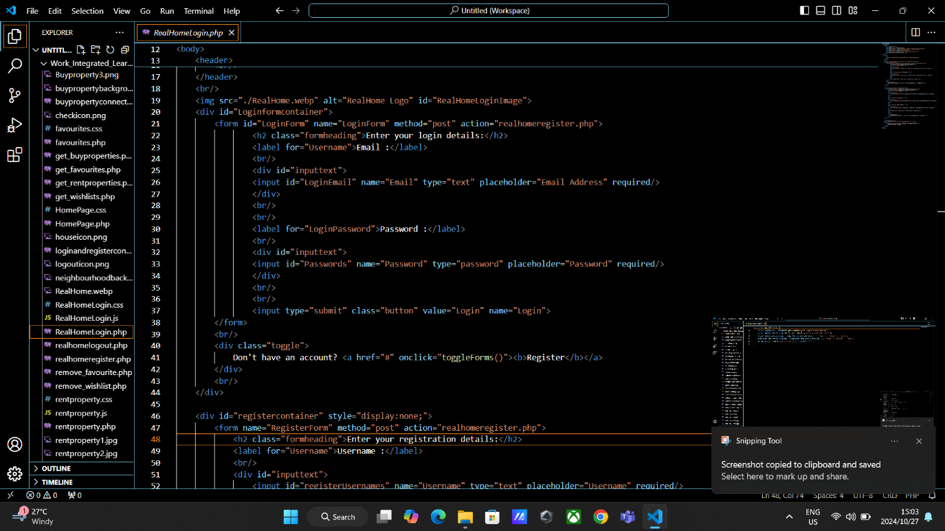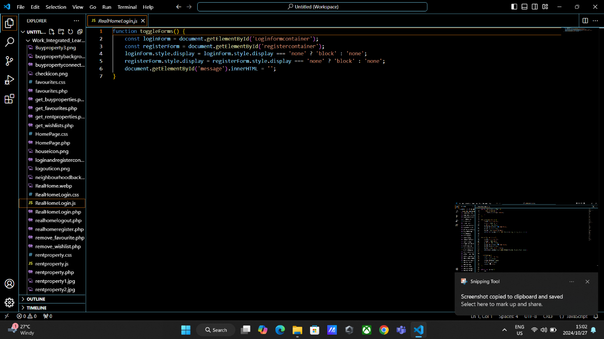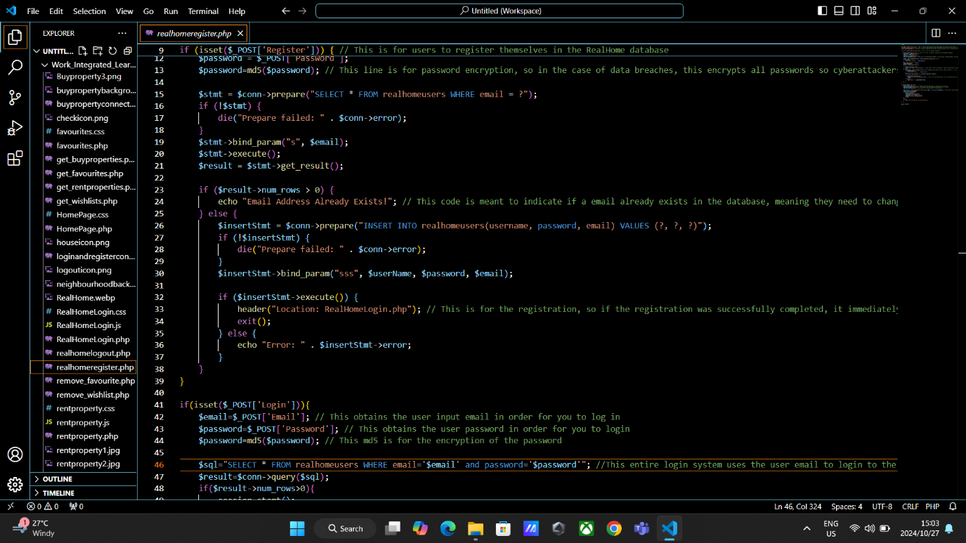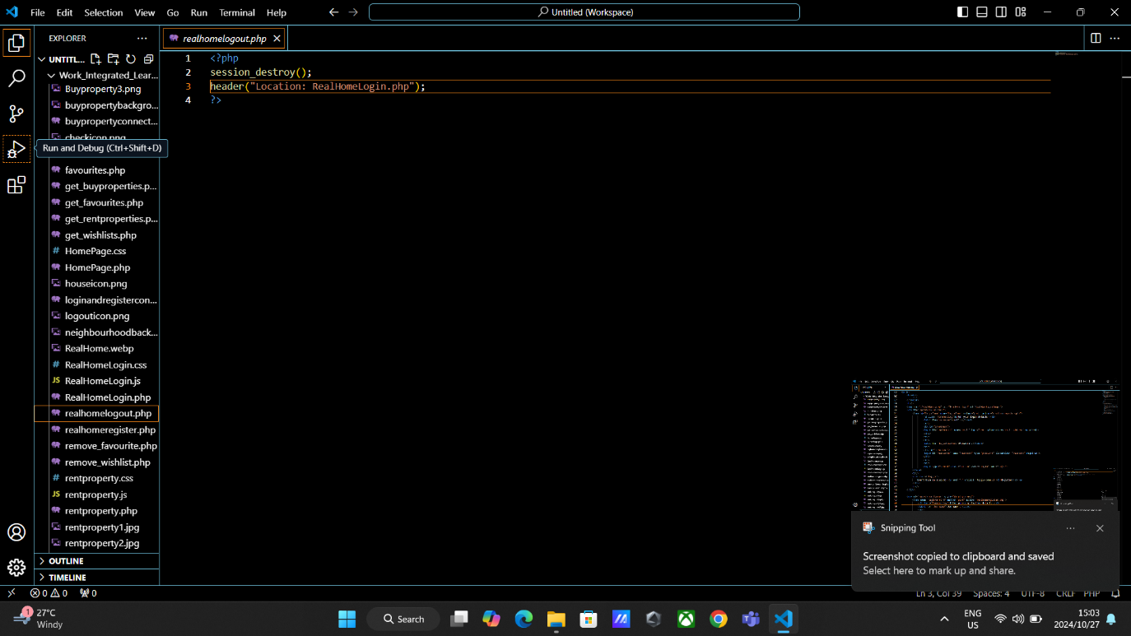

### Home Page Code

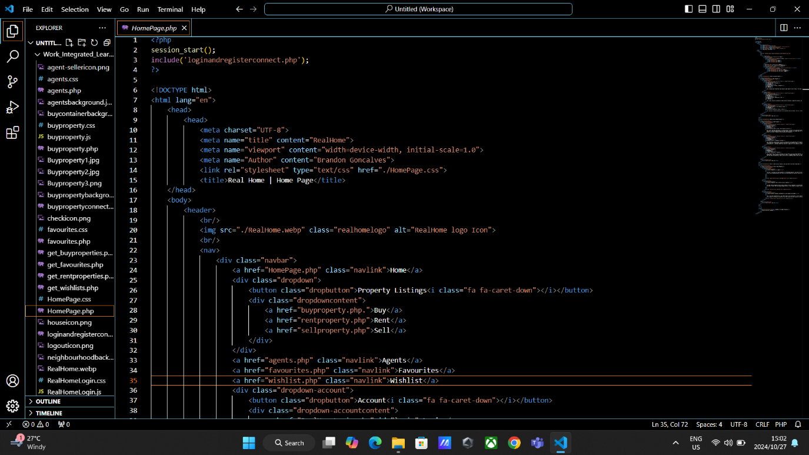

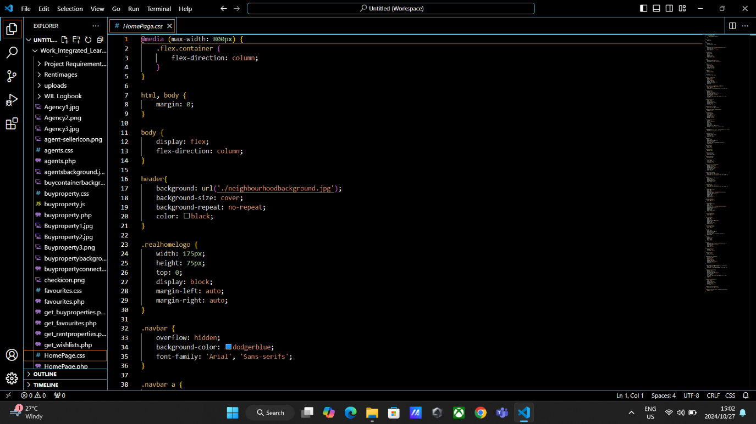

### Buy Property Code

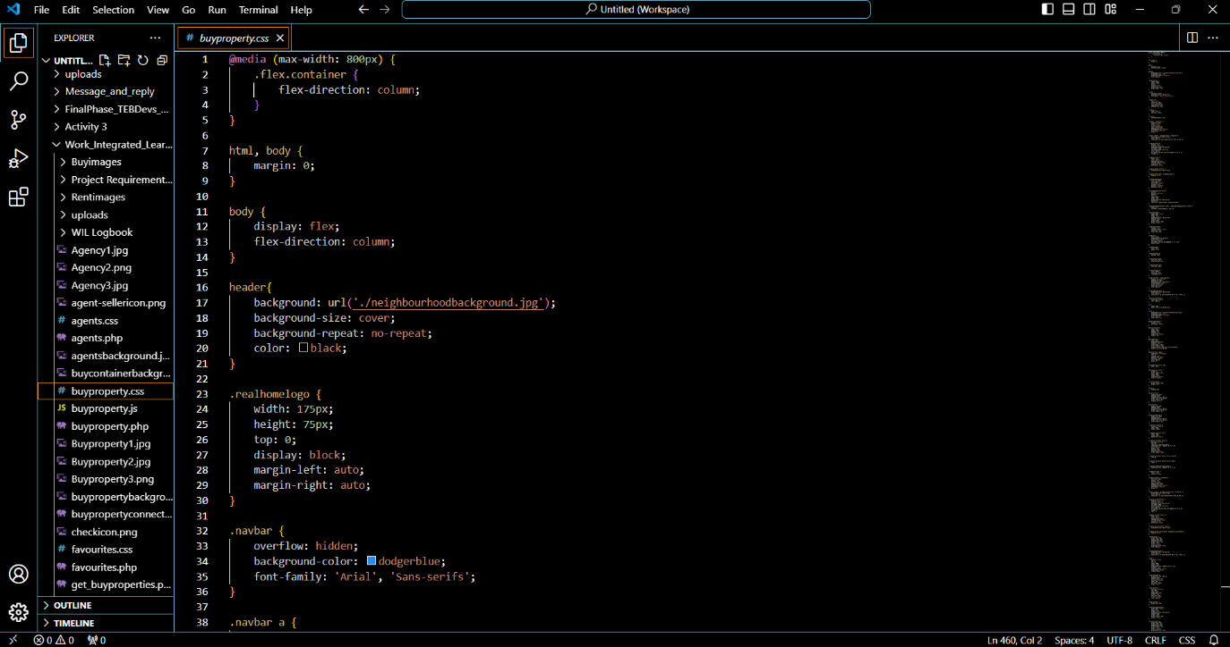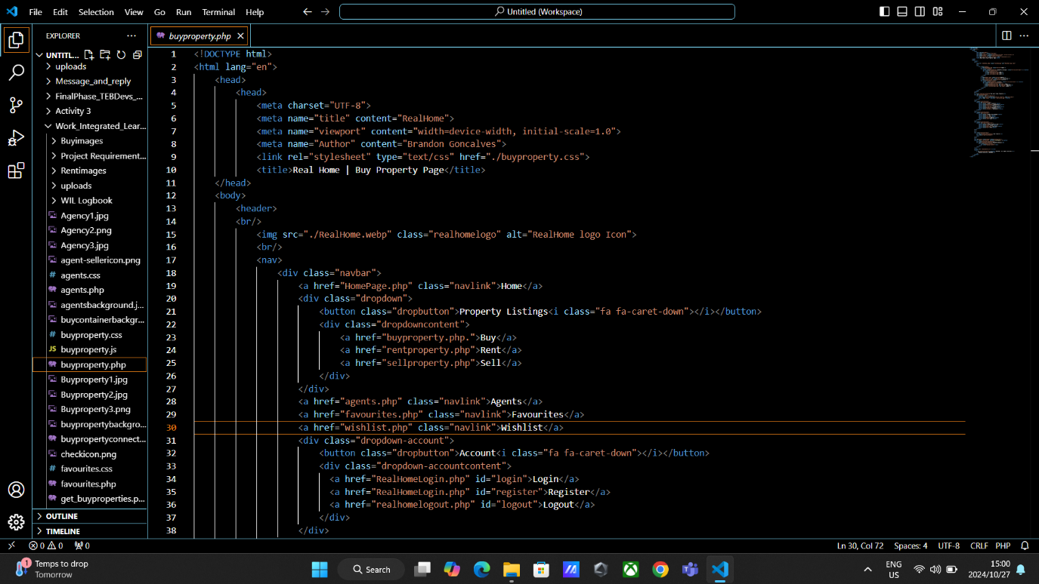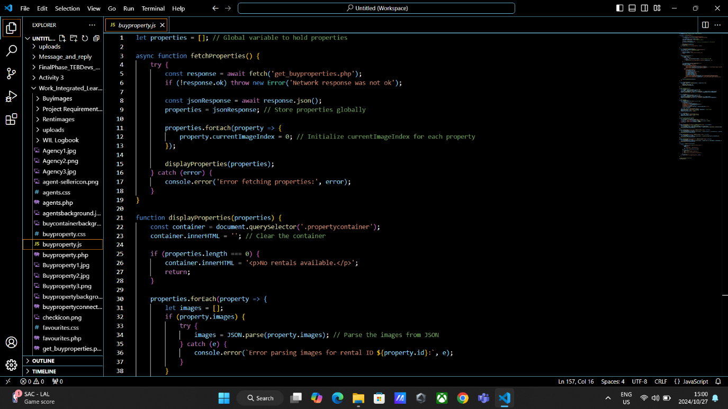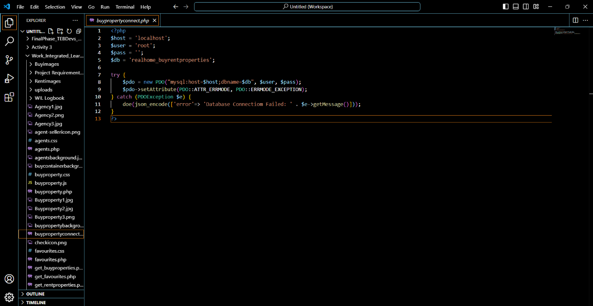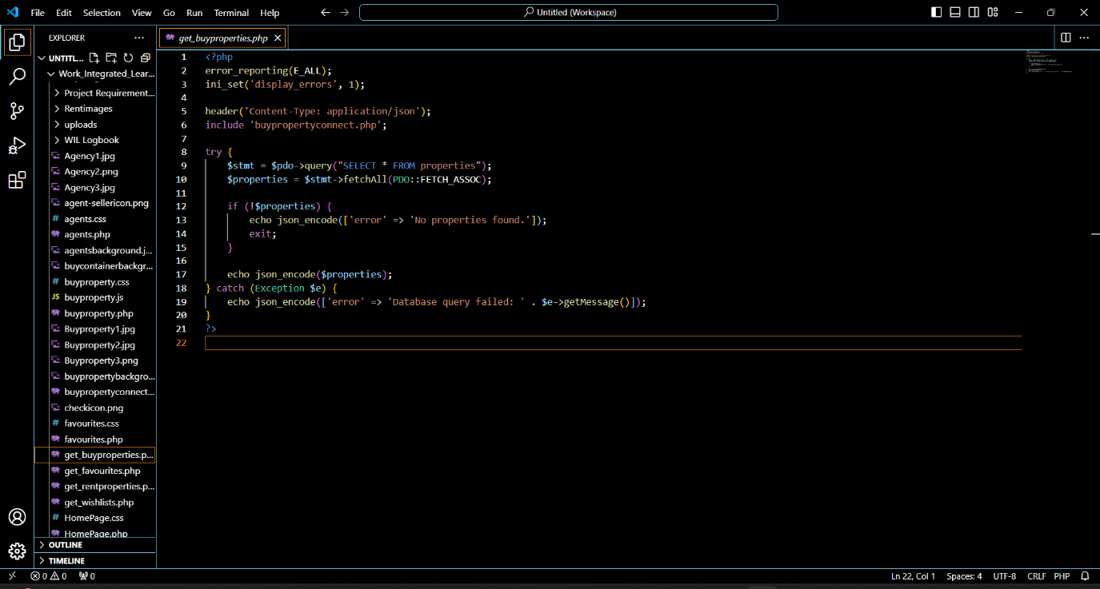

### Rent Property Code

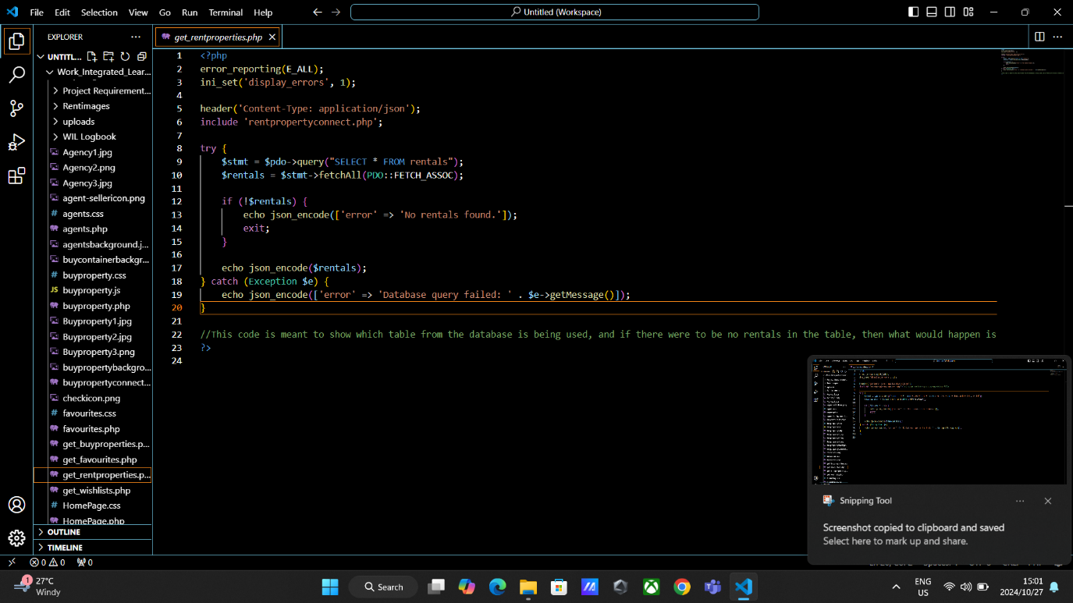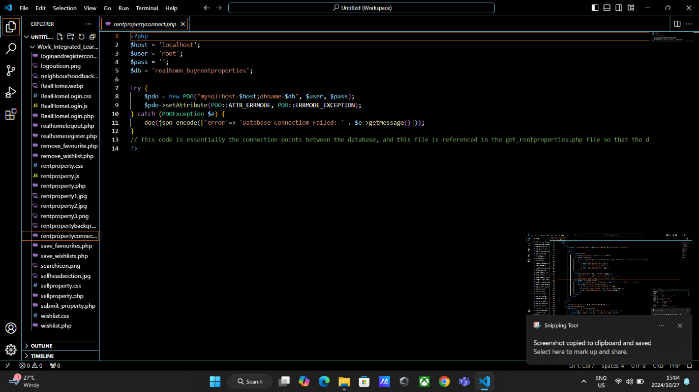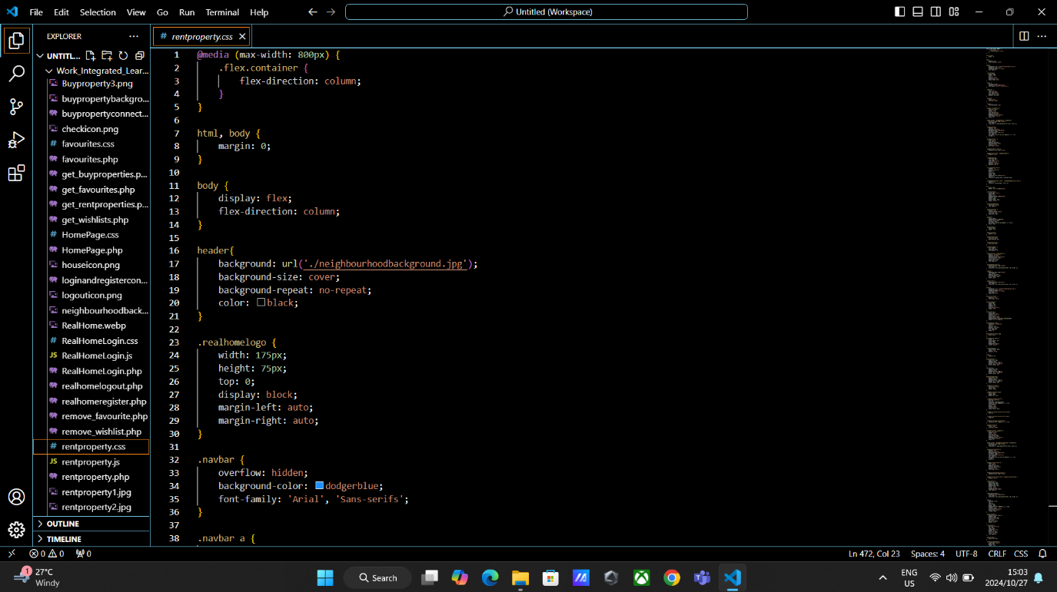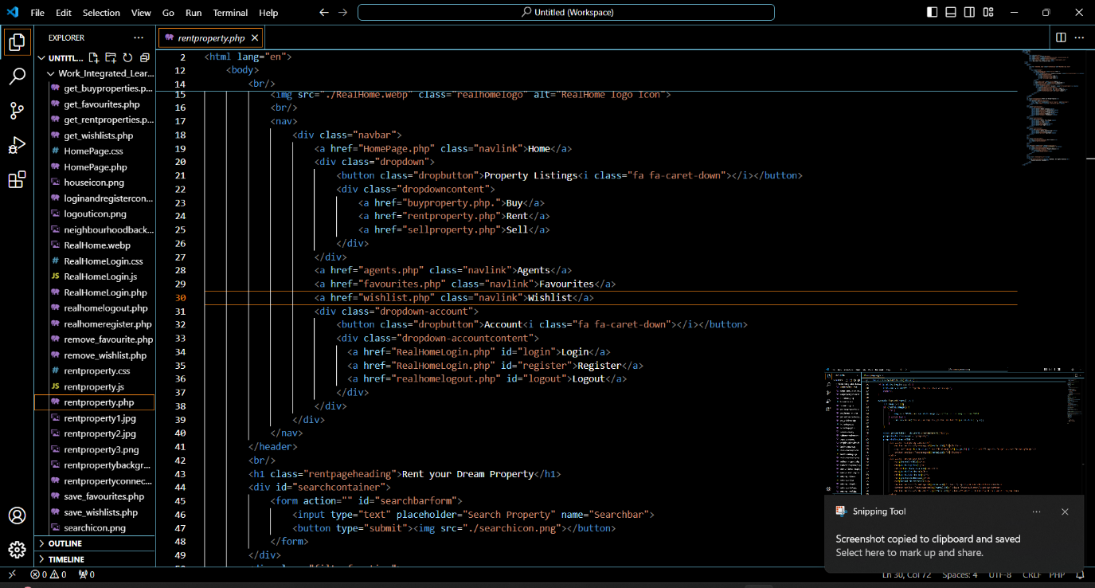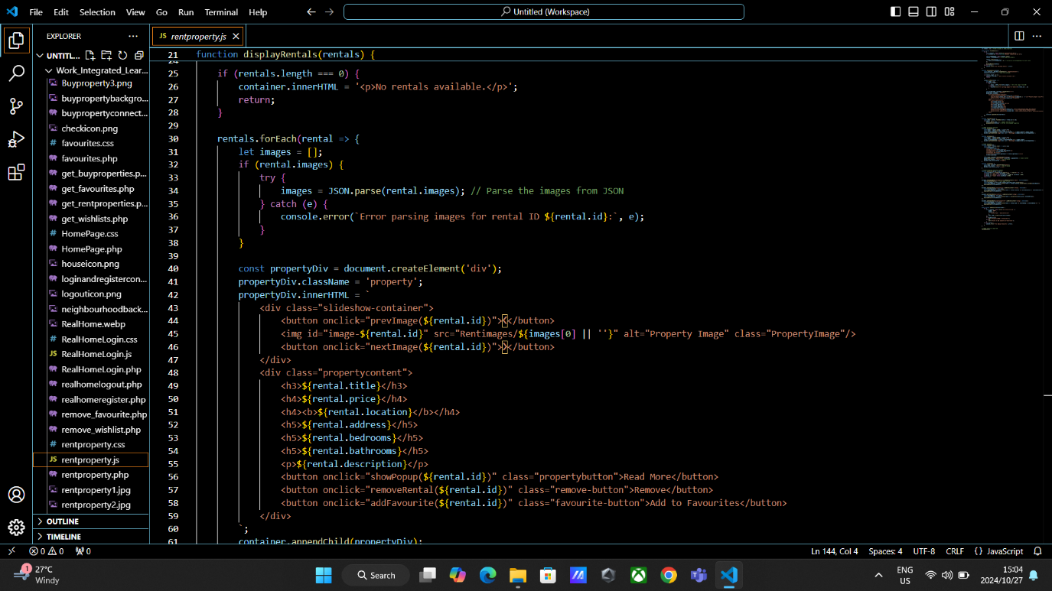

### Sell Property Code

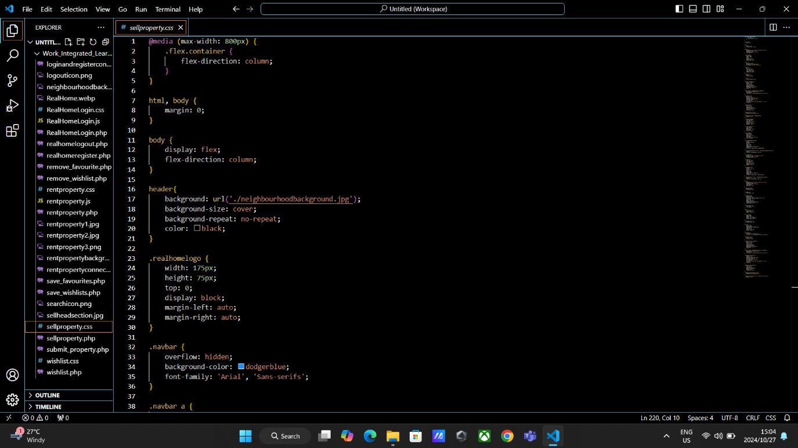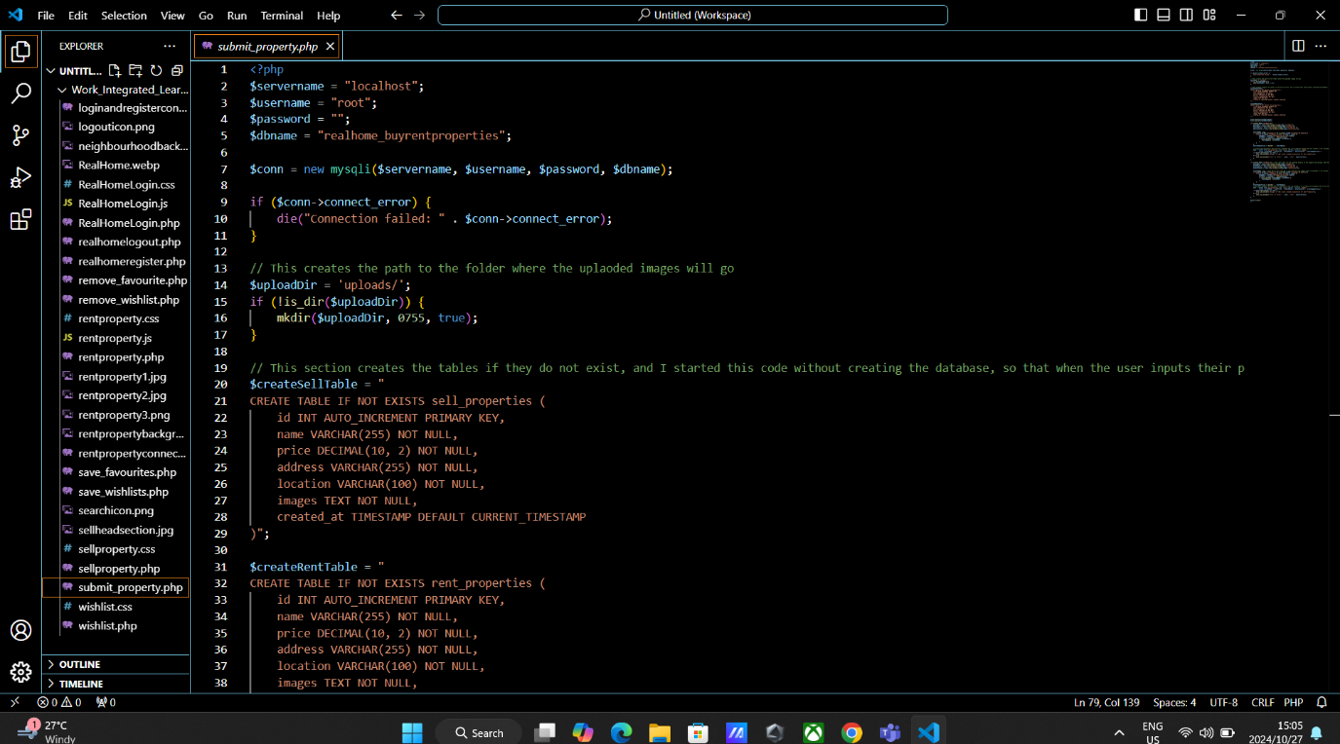

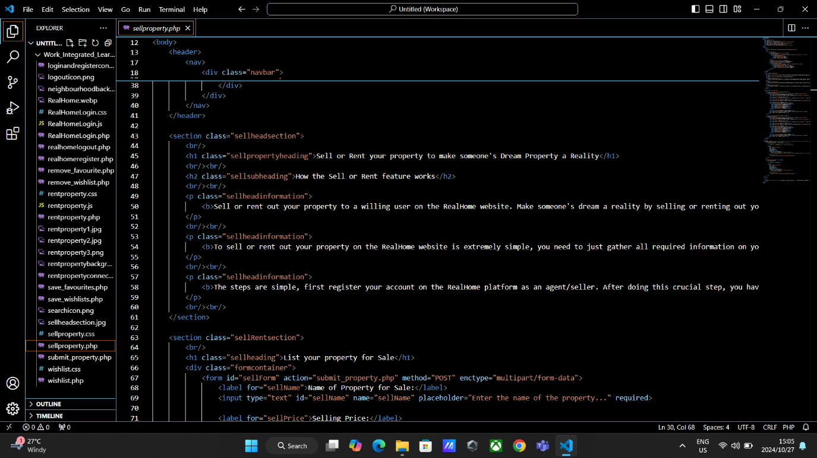

### Agents Code

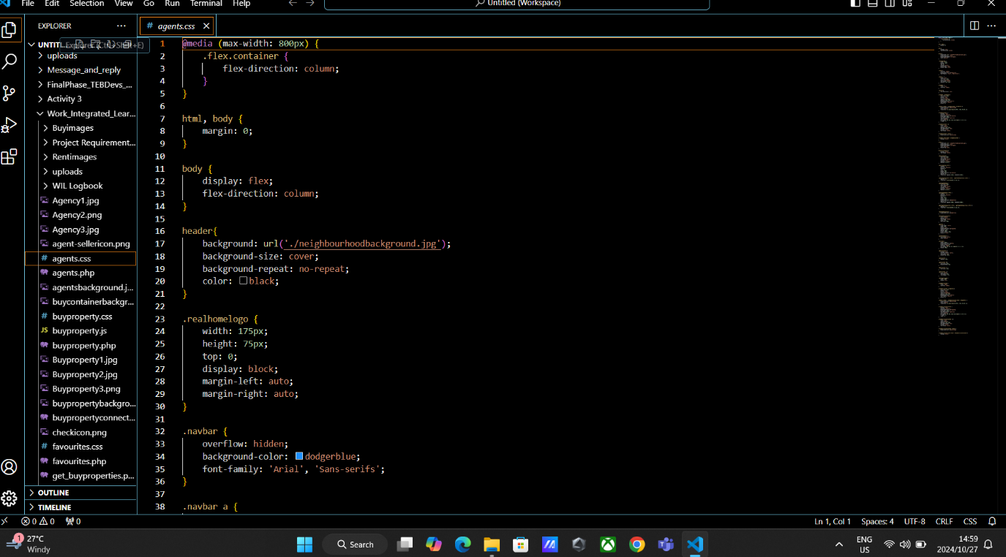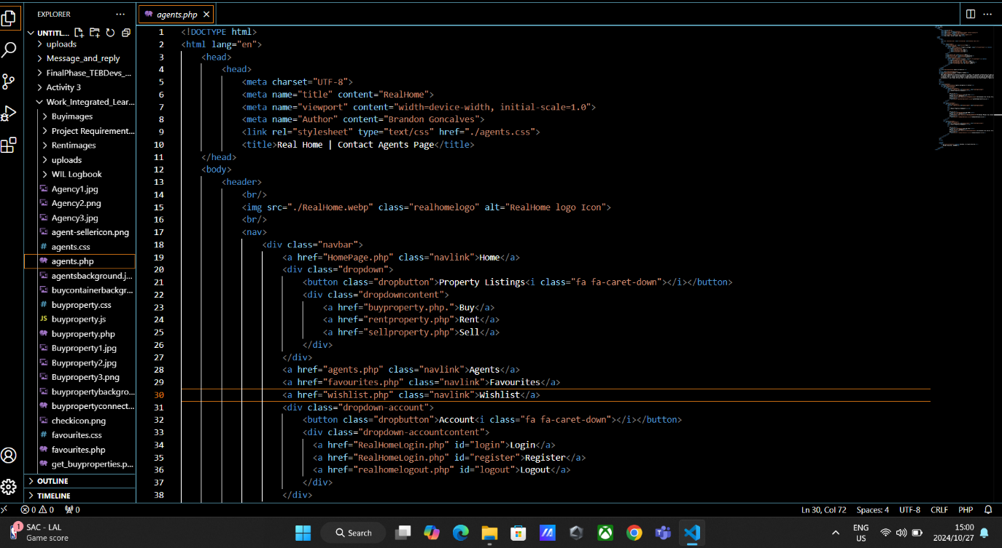

### Favourite Code

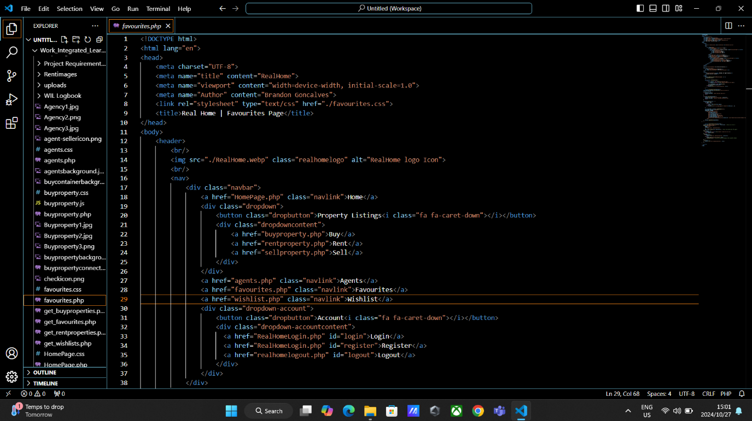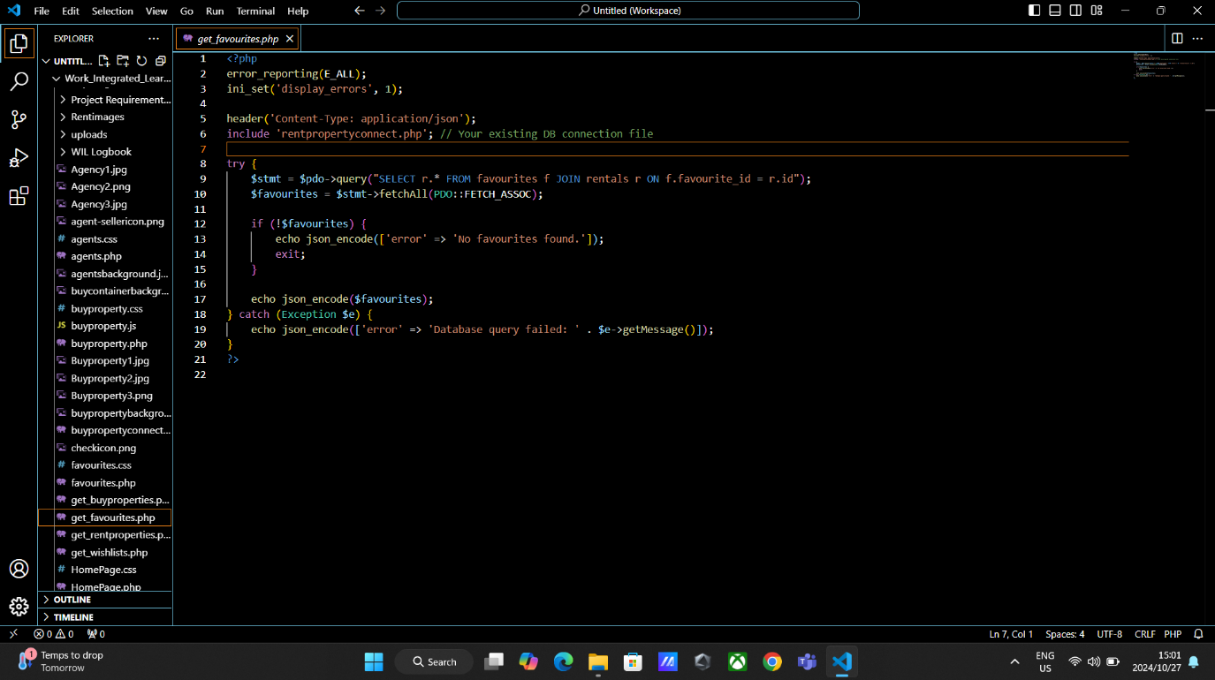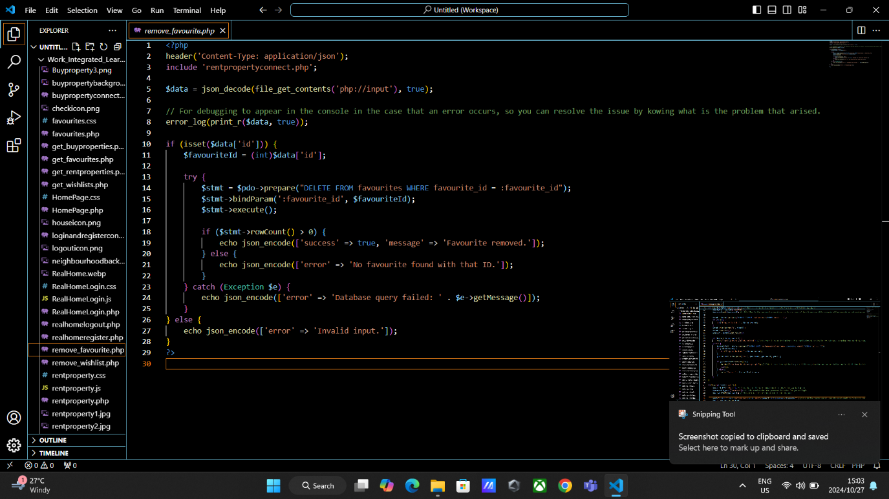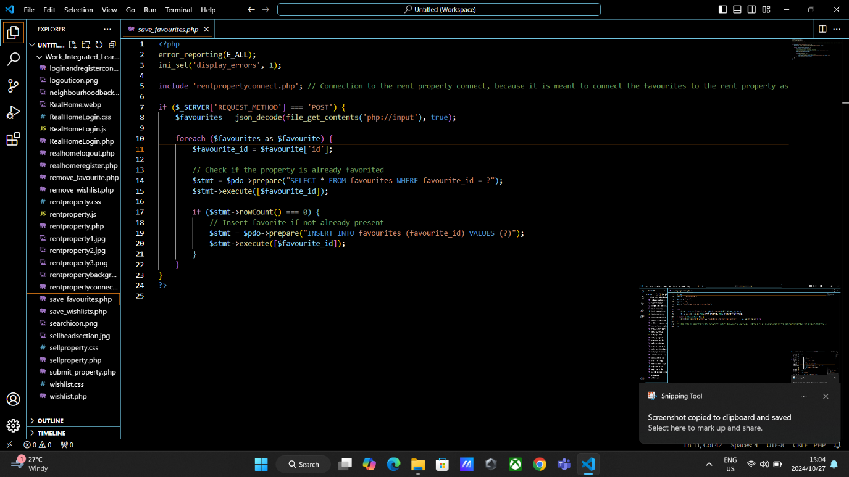

### Wishlist Code

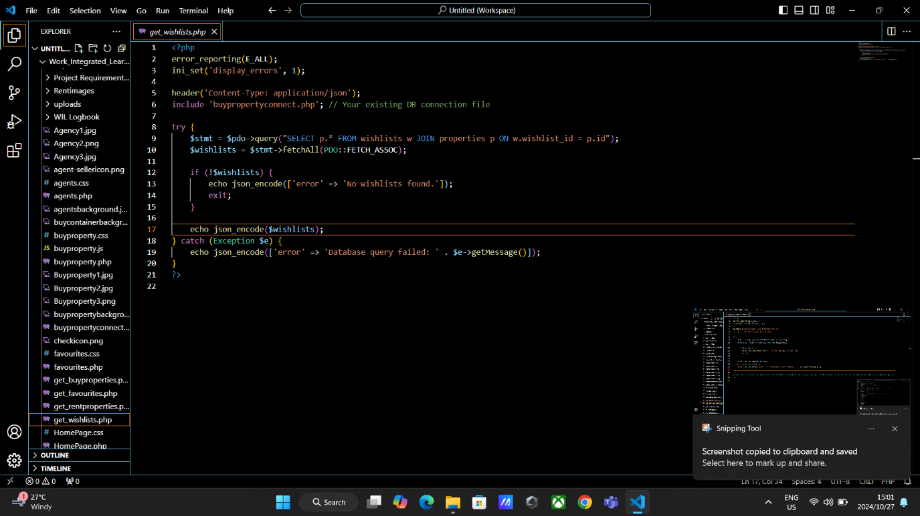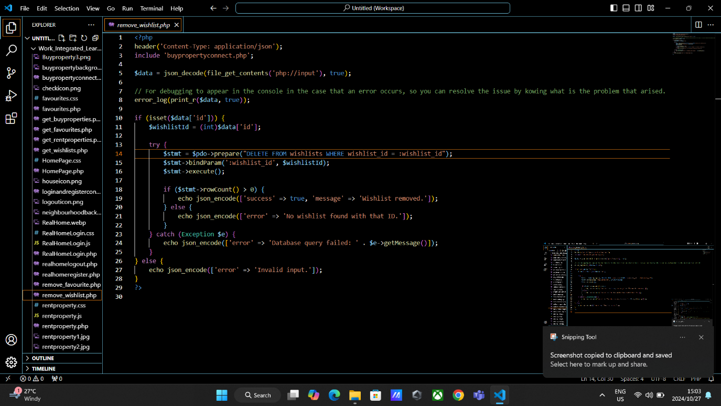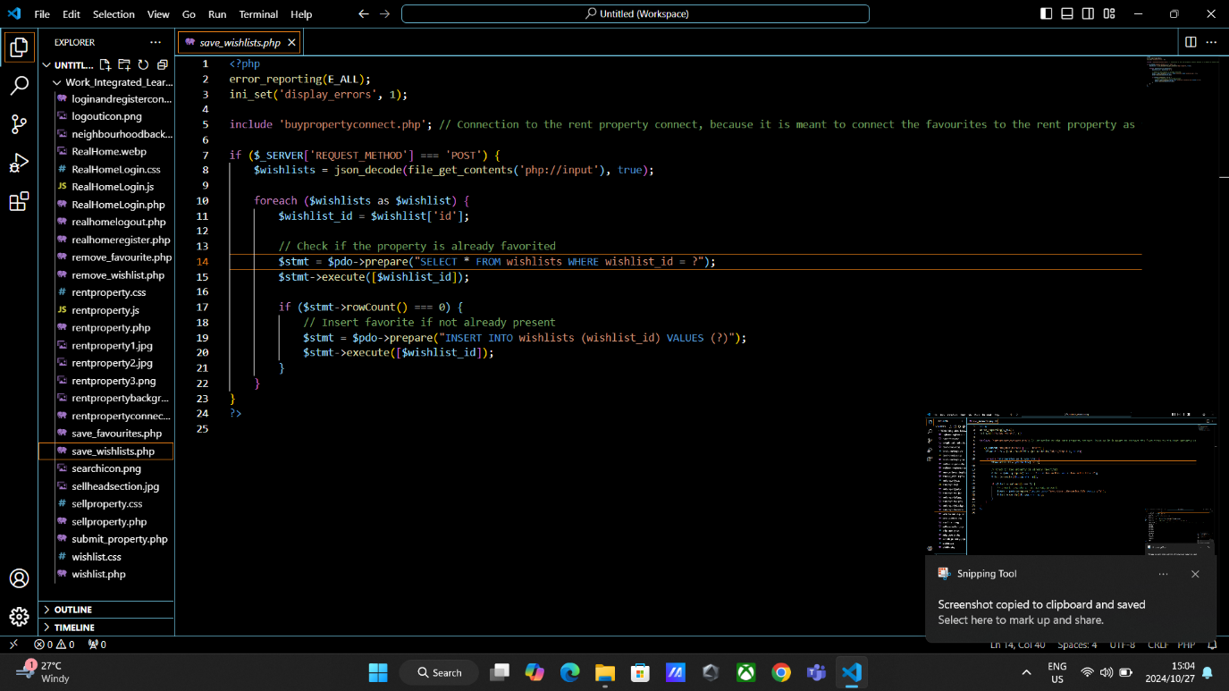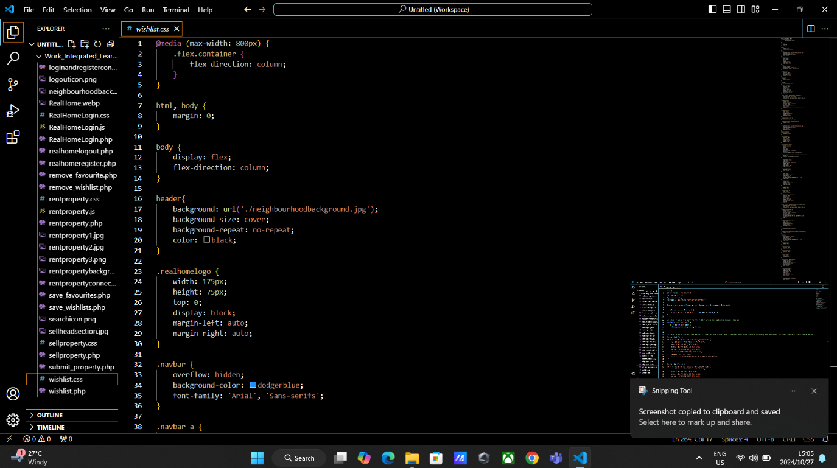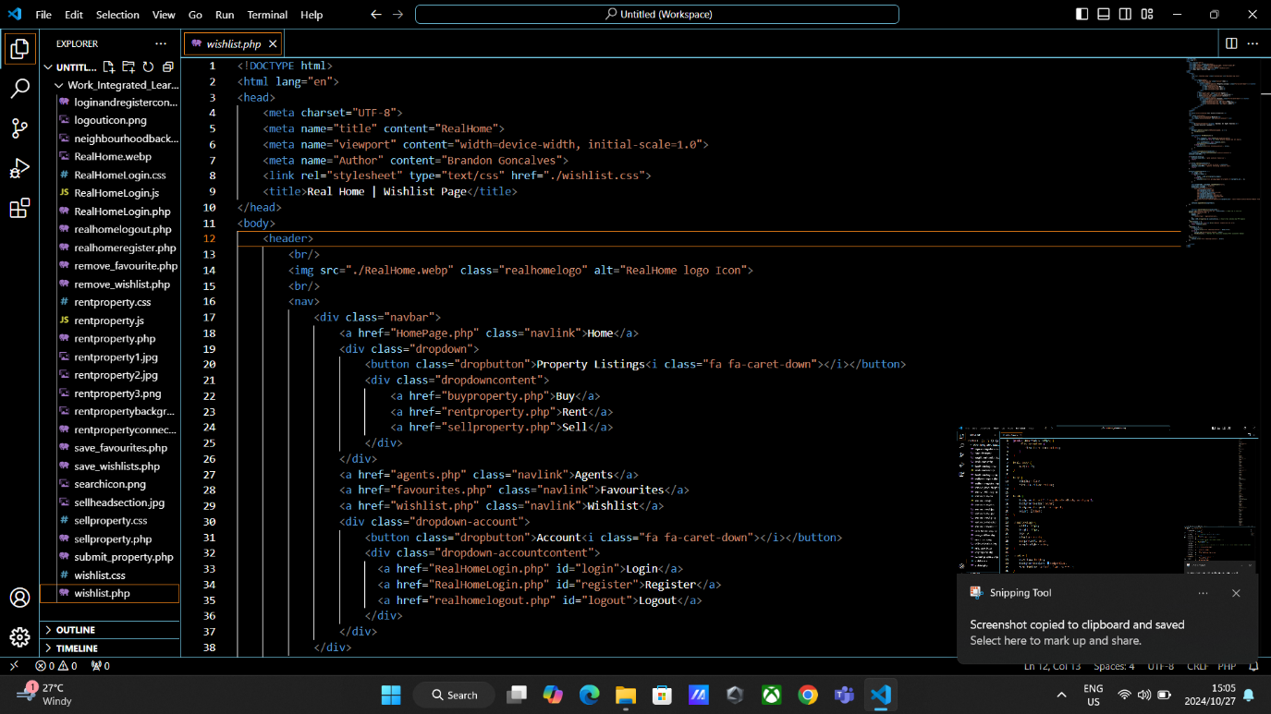

## Database

### Real Home User Database

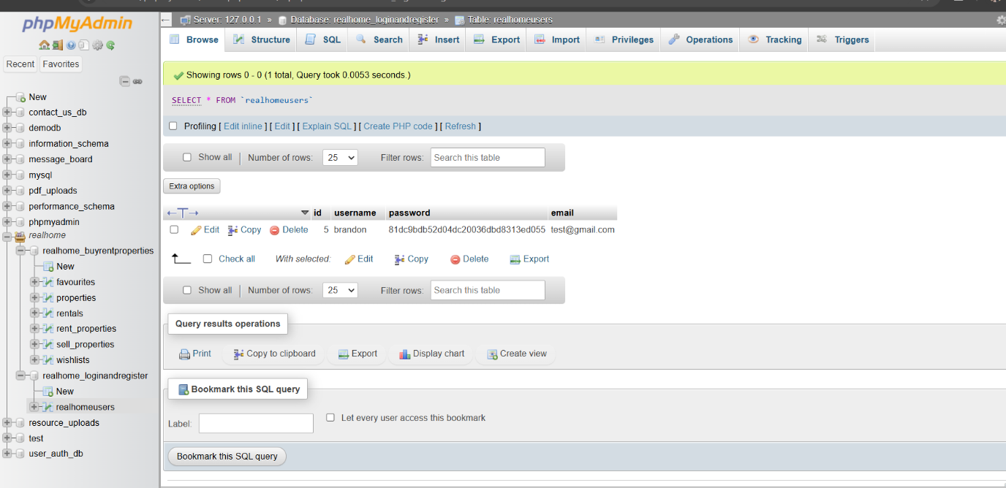

### Real Home Properties Database

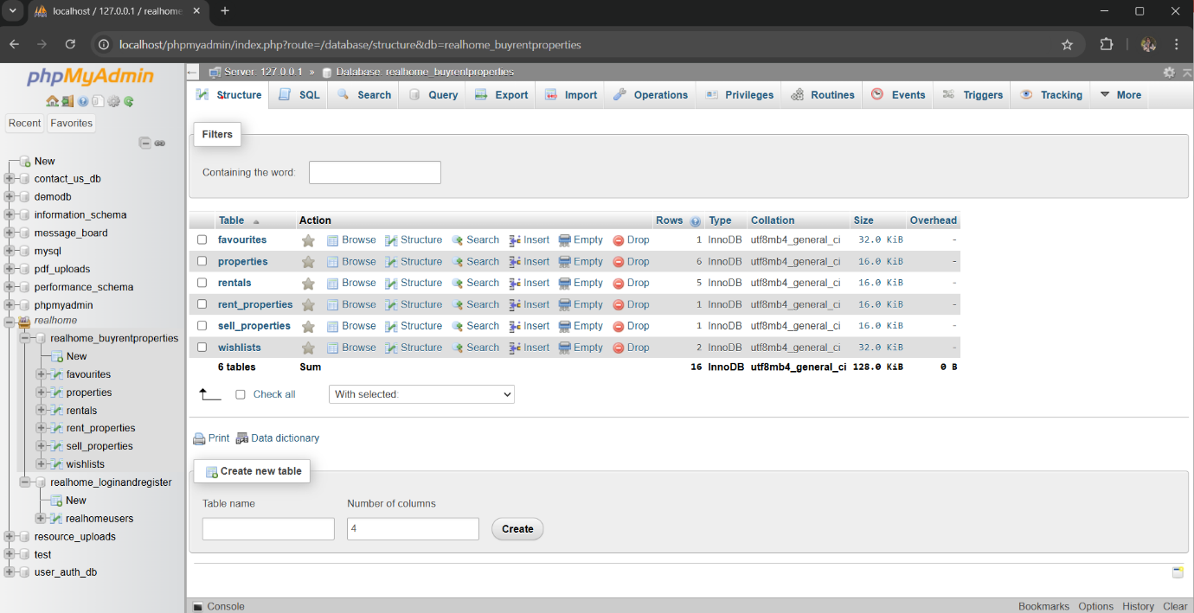

# References for resources used in WIL Project

# Task Completion Checklist

|  |  |  |  |
| --- | --- | --- | --- |
| Task completion checklist | | | |
| **No.** | **Task description** | **Status** | **Tick/check** |
| 1 | Define project requirements and scope | Completed | √ |
| 2 | Create wireframes and design the UI/UX | Completed | √ |
| 3 | Set up version control repository on GitHub | Not Started | ☐ |
| 4 | Develop frontend with HTML, CSS, JavaScript/React.js | Completed | √ |
| 5 | Develop backend with PHP/Node.js/Python | Completed | √ |
| 6 | Implement database with MySQL/PostgreSQL/MongoDB | Completed | √ |
| 7 | Integrate Google Maps API for property locations | Completed | √ |
| 8 | Integrate secure user authentication system | Completed | √ |
| 9 | Implement user registration and login features | Completed | √ |
| 10 | Develop property listing functionality | Completed | √ |
| 11 | Implement search and filter functionality | Completed | √ |
| 12 | Create property details page | Completed (Appears as pop up) | √ |
| 13 | Develop agent profiles and contact forms | Completed | √ |
| 14 | Implement favourites and wishlist features | Completed | √ |
| 15 | Ensure mobile responsiveness | Completed | √ |
| 16 | Perform thorough testing for bugs, performance, and security | Not Started | ☐ |
| 17 | Deploy website on cloud server | Not Started | ☐ |
| 18 | Ongoing maintenance and updates based on user feedback | Not Started | ☐ |
| 19 | Complete WIL logbook detailing time spent on tasks | Not Started | √ |
| 20 | Submit a zip file with signed logbook and PDF outlining phases | Not Started | ☐ |